**Excel Lab: Creating Advanced Charts**

In this lab, I learned how to create three types of advanced charts in Excel: a Sunburst chart, a Scatter chart, and a Histogram chart. This lab was completed as part of my “Data Visualization and Dashboards with Excel and Cognos” course.

**Dataset**: Modified Car Sales Dataset from Kaggle (Double click the icon)



**Task A: Create a Sunburst Chart**

Displayed Nissan's sales data in a hierarchical structure, showing various models and their sales.

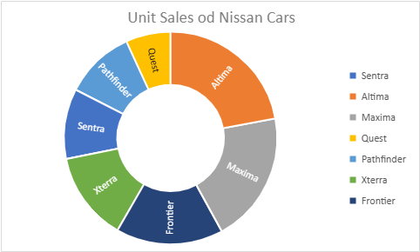

**Task B: Create a Scatter Chart**

Illustrated the relationship between car prices and their year resale values for a selected set of German manufacturers, making it easy to spot trends.

**Task C: Create a Histogram Chart**

Showed the distribution of German car prices across different price ranges, providing a clear picture of pricing trends within this subset of the dataset.

**Conclusion:** This lab helped me understand how to use Excel’s advanced charts to visualize complex data. The Sunburst chart was useful for displaying hierarchical relationships, the Scatter chart was effective for showing correlations between two variables, and the Histogram chart provided insights into the distribution of car prices.